Kingsborough Community College
The City University of New York
Department of Biological Sciences
BIO9100/MAT9100 M. T. Ortiz, Ph.D.
Biostatistics Computer Research Project

This semester in Biostatistics, each student will be involved in a Computer Research project on the Billion Oyster Project data generated at KCC. The results of your research will be added to those of other students and faculty at KCC working on this project. Your work is valuable to this project at KCC.

Introduction
The Billion Oyster Project (BOP) seeks to populate 35 billion oysters in New York Harbor by the year 2035 to filter and clean water and provide a food source. To accomplish this goal, organizations and individuals have joined the project and are growing and monitoring oysters at various locations in NY Harbor. Several professors in the KCC Department of Biological Sciences have joined the BOP, and with students, we are monitoring a site at the end of Sheepshead Bay (corner of West End and Emmons Avenues). A set of spats (juvenile oysters) were counted, measured, and then placed in the water in November 2019. They were counted and measured again in October 2020. The counts and measurements for both dates are in the Raw Data table on Blackboard in Course Information in “91 Computer Research Project”. Oysters are measured across their long axis (height), as shown in the figures below:

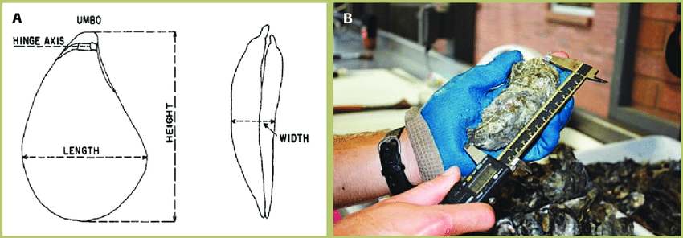
(Photo is from https://www.researchgate.net/figure/a-Diagram-of-the-height-length-and-width-measurements-of-an-oyster-shell-from_fig11_260002282)

Your Computer Research Project
This semester each student in Biostatistics will use the raw data to conduct research and submit a computer research project report. The completed report will be due later in the semester, but each piece will be submitted and due at various points in the semester.

The Parts of the Project
Note: If a part is not submitted on time, you will lose the points for that part. It is important to submit each part on time to do well on the entire project. This project is due in parts so that I can provide feedback and you can correct any issues before submitting the final report.
Part 1 – Description, References, and Hypothesis (Due 9am, Fri, 3/19/2021)
- Write a short (one paragraph) Description of the BOP. Do not copy and paste text from a website or from this document. This will result in point losses. Use your own words. Here is a starting point: https://www.billionoysterproject.org
- Cite the References you used to write part “a” above. Use at least two references. Cite the references using APA format (for how to cite a website see here: https://www.scribbr.com/apa-examples/website/) (for how to cite an article see here: https://apastyle.apa.org/style-grammar-guidelines/references/examples/journal-article-references)
- Create and state a Hypothesis for your computer research project.
- Upload your Description, References and Hypothesis in a Word document to File Exchange in your Group on Blackboard.
Part 2 – Descriptive Statistics and Graph (Due 9am, Fri 4/9/2021)
- Using Excel, calculate the following descriptive statistics on the raw data: mean, median, mode, range, standard deviation, standard error of the mean. Place these data in the following table:
Name:
 | November 2019 | October 2020
Mean
Median
Mode
Range
Standard Deviation
Standard Error of the Mean
- Create a graph of the means and standard deviations. You may use Excel to do this or provide a photo of a hand-drawn graph.
- Upload the Table and Graph in a Word document to File Exchange in your Group on Blackboard.
Part 3 – Binomial Criteria Test (Due 9am, Fri, 4/23/2021)
  - Using the four criteria for a Binomial Distribution and the Raw Data, answer the following question in a paragraph:
“Do the raw data meet the criteria for a Binomial Distribution”? Provide support for your answer.
  - Upload your answer as a Word document to File Exchange in Your Group on Blackboard.
Part 4 – t-Test (Due 9am, 5/7/2021)
- Use Excel to perform a t-Test on the raw data. Remember to use the form for a sample. Is the result significant? Provide the results and an explanation in a paragraph as a Word document uploaded to File Exchange in your Group on Blackboard.
Part 5 – Discussion and Conclusion (Due as part of the final report at 5 pm on 5/21/21)
- In a paragraph or two discuss the results of your analysis of the data.
- Provide a conclusion, based on your results, where you accept or reject your hypothesis.

The Final Report
Due 5pm, Fri 5/21/21 as a MS Word document uploaded to File Exchange in your Group on Blackboard.
Your report must include all the parts in one Word document:
Description
Hypothesis
Descriptive Statistics
Graph
Binomial Criteria Test
t-Test
Discussion
Conclusion
References

How the project will be graded:
Part 1 – 12 points (Description 3 points, References 6 points, Hypothesis 3 points)
Part 2 – 11 points (Descriptive Statistics 6 points, Graph 5 points)
Part 3 – 5 points (Binomial criteria 5 points)
Part 4 – 7 points (Discussion 5 points, Conclusion 2 points)
Final Report – 65 points
Description – 5 points
Hypothesis – 3 points
Descriptive Statistics – 10 points
Graph – 10 points
Binomial Criteria Test – 4 points
t-Test – 10 points
Discussion – 10 points
Conclusion – 3 points
References – 5 points
Following instructions – 5 points

